ENVIRONMENTAL REPORT

(49 C.F.R. 1105.7)

Docket No. AB-1237 Sub. # 1X

NEW HAMPSHIRE DEPARTMENT OF TRANSPORTATION --ABANDONMENT EXEMPTION-- IN GRAFTON COUNTY, NH

- Proposed Action and Alternatives. Describe the proposed action, including commodities transported, the planned disposition (if any) of any rail line and other structures that may be involved, and any possible changes in current operations or maintenance practices. Also describe any reasonable alternatives to the proposed action. lnclude a readable, detailed map and drawings clearly delineating the project.

New Hampshire Department of Transportation ("NHDOT") proposes to abandon 6.86 miles of rail line located between Milepost C113, Station 995+66 to Milepost C119.86, Station 1359+77, between Industrial Drive in Littleton, NH, and a point 3.35 miles east of the Littleton, NH/Bethlehem, NH town line. Upon receipt of abandonment authority, NHDOT intends to remove the rail, track material, and cross ties. The culverts and ballast will remain in place along the Line.

The Line has had no local or overhead traffic for well over two years; in fact, no traffic of any kind or nature has moved over the Line since 1998. Also, any future overhead traffic can be rerouted over other rail lines. Because of the lack of traffic on the Line only very limited maintenance has been performed on the Line for some time. Therefore, the proposed abandonment will have no impact on rail freight operations and maintenance practices on the Line.

The only alternative to abandonment would be to not abandon the Line and forego the opportunity costs from salvaging the Line.

A map of the proposed abandonment is attached hereto as Exhibit 1.

- Transportation System. Describe the effects of the proposed action on regional or local transportation systems and patterns. Estimate the amount of traffic (passenger or freight) that will be diverted to other transportation systems or modes as a result of the proposed action.

No passenger or freight traffic will be diverted to other modes as a result of the proposed abandonment. No local or overhead traffic has moved over the Line since 1998. Therefore, the proposed abandonment will have no adverse effects on local or regional transportation systems or patterns.

- Land Use. (i) Based on consultation with local and/or regional planning agencies and/or a review of the official planning documents prepared by such agencies, state whether the proposed action is consistent with existing land use plans. Describe any inconsistencies. (ii) Based on consultation with the U.S. Soil Conversation Service, state the effect of the proposed action on any prime agricultural land. (iii) If the action affects land or water uses within a designated coastal zone, include the coastal zone information required by 1105.9. (iv) If the proposed action is an abandonment, state whether or not the right-of-way is suitable for alternative public use under 49 U.S.C. § 10905 and explain why.

- NHDOT and the New Hampshire Department of Resources and Economic Development (NHDRED) held extensive consultations with the towns of Littleton and Bethlehem, NH beginning in 2014. Both towns have been fully involved with this process and the abandonment application is the result of these discussions.

- There are no known prime agricultural lands adjacent to the right-of-way of the Line. Thus, there is no impact to lands of this nature.

- Not applicable.

- Input was received from all of the current recreational user groups. All agreed the highest and best use of this rail corridor is as a recreational trail. There will be a lot of bicycle use and walking in the downtown Littleton area through which the right-of-way passes.

- Energy. (i) Describe the effect of the proposed action on transportation of energy resources. (ii) Describe the effect of the proposed action on recyclable commodities. (iii) State whether the proposed action will result in an increase or decrease in overall energy efficiency and explain why. (iv) If the proposed action will cause diversions from rail to motor carriage of more than: (A) 1,000 rail carloads a year; or (B) an average of 50 rail carloads per mile per year for any part of the affected line, quantify the resulting net change in energy consumption and show the data and methodology used to arrive at the figure given.

- The proposed abandonment will have no effect on the transportation of energy resources.

- The proposed abandonment will have no effect on the transportation of recyclable commodities.

- The proposed abandonment will have no adverse effect on overall energy efficiency since no local or overhead traffic has moved over the Lines in well over 2 years. The traffic that previously moved over the Lines has been transferred either to other modes or other routings.

- The proposed abandonment will not cause the diversion of any rail traffic to motor carriage since no local or overhead traffic has been handled over the Lines in well over 2 years.

(5) Air. (i) If the proposed action will result in either: (A) An increase in rail traffic of at least 100 percent (measured in gross ton miles annually) or an increase of at least eight trains a day on any segment of rail line affected by the proposal, or (B) an increase in rail yard activity of at least 100 percent (measured by carload activity), or (C) an average increase in truck traffic of more than 10 percent of the average daily traffic or 50 vehicles a day on any affected road segment, quantify the anticipated effect on air emissions. For a proposal under 49 U.S. C.§ 10901 (or§ 10505) to construct a new line or re-institute service over a previously abandoned line, only the eight train a day provision in sub-section (5)(i)(A) will apply. (ii) If the proposed action affects a class I or non-attainment area under the Clean Air Act, and will result in either: (A) an increase in rail traffic of at least 50 percent (measured in gross ton miles annually) or an increase of at least three trains a day on any segment of rail line; (B) an increase in rail yard activity of at least 20 percent (measured by carload activity); or (C) an average increase in truck traffic of more than 10 percent of the average daily traffic or 50 vehicles a day on a given road segment, then state whether any expected increased emissions are within the parameters established by the State Implementation Plan. However, for a rail construction under 49 U.S.C. § 10901 (or 49 U.S. C.§ 10505), or a case involving the re institution of service over a previously abandoned line, only the three train a day threshold in this item shall apply. (iii) If transportation of ozone depleting materials (such as nitrogen oxide and freon) is contemplated, identify: the materials and quantity; the frequency of service; safety practices (including any speed restrictions); the applicant's safety record (to the extent available) on derailments, accidents and spills; contingency plans to deal with accidental spills; and the likelihood of an accidental release of ozone depleting materials in the event of a collision or derailment.
- The proposed abandonment will not result in meeting or exceeding the specified thresholds.

- The proposed abandonment will not result in meeting or exceeding the specified thresholds.

- The proposed abandonment will not affect the transportation of ozone depleting materials.

(6) Noise. If any of the thresholds identified in item (5)(i) of this section are surpassed, state whether the proposed action will cause: (i) an incremental increase in noise levels of three decibels Ldn or more; or (ii) an increase to a noise level of 65 decibels Ldn or greater. If so, identify sensitive receptors (e.g., schools, libraries, hospitals, residences, retirement communities, and nursing homes) in the project area, and quantify the noise increase for these receptors if the thresholds are surpassed.

Not applicable.

- Safety. (i) Describe any effects of the proposed action on public health and safety (including vehicle delay time at railroad grade crossings). (ii) If hazardous materials are expected to be transported, identify: the materials and quantity; the frequency of service; whether chemicals are being transported that, if mixed, could react to form more hazardous compounds; safety practices (including any speed restrictions); the applicant's safety record (to the extent available) on derailments, accidents and hazardous spills; the contingency plans to deal with accidental spills; and the likelihood of an accidental release of hazardous materials. (iii) If there are any known hazardous waste sites or sites where there have been known hazardous materials spills on the right-of-way, identify the location of those sites and the types of hazardous materials involved.

- The proposed abandonment will have no detrimental effects on public health and safety.

- The proposed abandonment will not affect the transportation of hazardous materials.

- There are no known hazardous material waste sites or sites where known hazardous material spills have occurred on or along the rail corridor of the Line.

- Biological Resources. (i) Based on consultation with the U.S. Fish and Wildlife Service, state whether the proposed action is likely to adversely affect endangered or threatened species or areas designated as a critical habitat, and if so, describe the effects. (ii) State whether wildlife sanctuaries or refuges, National or State parks or forests will be affected, and describe any effects.

- NHDRED believes that there are no known endangered or threatened species or areas designated as a critical habitat along the Line.

- NHDRED does not believe that any wildlife sanctuaries or refuges, National or State parks or forests would be adversely affected by the proposed abandonment. There are no refuges or national or state parks that abut the Line.

- Water. (i) Based on consultation with State water quality officials, state whether the proposed action is consistent with applicable Federal, State or local water quality standards. Describe any inconsistencies. (ii) Based on consultation with the U.S. Army Corps of Engineers, state whether permits under section 404 of the Clean Water Act (33 U.S. C.§ 1344) are required for the proposed action and whether any designated wetlands or 100-year flood plains will be affected. Describe the effects. (iii) State whether permits under section 402 of the Clean Water Act (33 U.S.C. § 1342) are required for the proposed action.

- The proposed abandonment, in the opinion of both NHDOT and NHDRED, will be consistent with applicable state and federal water quality standards.

- The proposed abandonment will not result in any discharge of dredged or fill material into any waters. There will be no impact from the abandonment on any designated wetlands or in 100 year flood plains. The rail corridor and surface will remain intact. Rails and ties would be removed from the surface.

- Proposed Mitigation. Describe any actions that are proposed to mitigate adverse environmental impacts, indicating why the proposed mitigation is appropriate.

Not applicable.

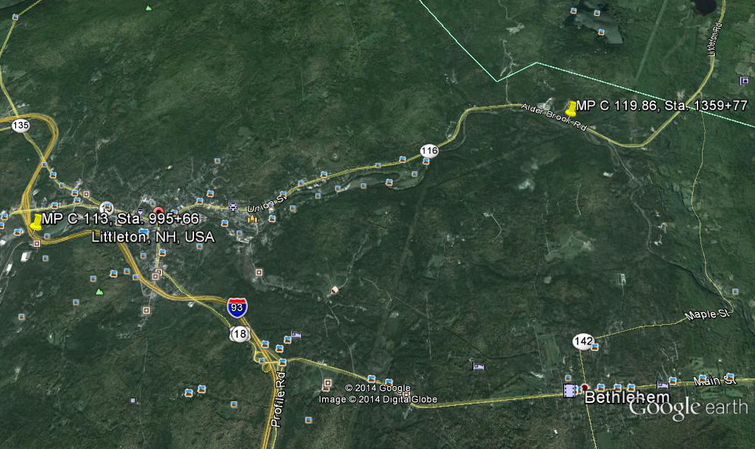

State-owned Berlin Branch Railroad Corridor – Proposed abandonment MP C 113, Station 995+66 to MP C 119.86, Station 1359+77. Towns of Littleton and Bethlehem, NH.

